Exploring Magnets

Case study-
A toy manufacturing workshop, engineers were testing different configurations of small bar magnets used in magnetic building blocks. During testing, one engineer, Rina, noticed that when the north pole of one magnet was brought close to the north pole of another, the magnets pushed away from each other. However, when the north pole of one magnet was brought near the south pole of another, they stuck together strongly. She further observed that some defective magnets had lost their ability to attract or repel, likely due to exposure to high heat. Rina made a chart of combinations to classify the forces of attraction and repulsion to ensure correct magnet alignment in all toy sets.

What happens when the north pole of one magnet is brought near the north pole of another magnet?
- They attract each other
- They repel each other
- They cancel each other
- No force acts between them

Which combination of poles causes attraction between two magnets?
  - North–North
  - South–South
  - North–South
  - Both a and b

If a magnet is heated strongly and loses its magnetic properties, it is said to be:
  - Overcharged
  - Demagnetized
  - Electrified
  - Polarized

Which of the following is true about magnetic poles?

Only north poles attract metals

Like poles attract; unlike poles repel

Like poles repel; unlike poles attract

Only south poles repel

What will happen if you will rub similar poles of two magnet (i.e. North- North or South- South)?

The magnet will lose its properties.

One may feel a sense of attraction.

Some heat may be produced.

Both a and c

Assertion (A): Rina created a chart of magnet pole combinations to ensure toys worked properly.

Reason (R): Only unlike poles of magnets can repel each other.

Both A and R are true, and R is the correct explanation of A.

Both A and R are true, but R is not the correct explanation of A.

A is true, but R is false.

A is false, but R is true.

Assertion (A): Magnetism is strongest at the poles of a magnet.

Reason (R): Magnetic force is not uniform throughout the magnet.

Both A and R are true and R is the correct explanation of A.

Both A and R are true but R is not the correct explanation of A.

A is true but R is false.

A is false but R is true.

If you break a magnet into 6 pieces, how many north and how many south poles would there be in all?

N= 6, S= 6

N= 3, S= 3

N= 12, S= 12

N= 6, S= 12

Which of the following is true about magnets?

Every magnet has only two poles.

Different shapes of magnets have different number of poles.

Poles of the magnet can be isolated.

Both a and c.

There are two toy cars X and Y in which Y is fixed, as shown in figure. A magnet is mounted on car X which can move. To move car X away from Y, Y should have a magnet placed on the top

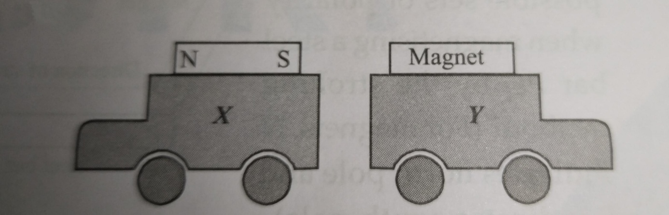
with the north pole pointing towards X.

With South pole pointing towards X.

With either pole pointed towards X.

Car X cannot be moved away.

